Spring Form Example

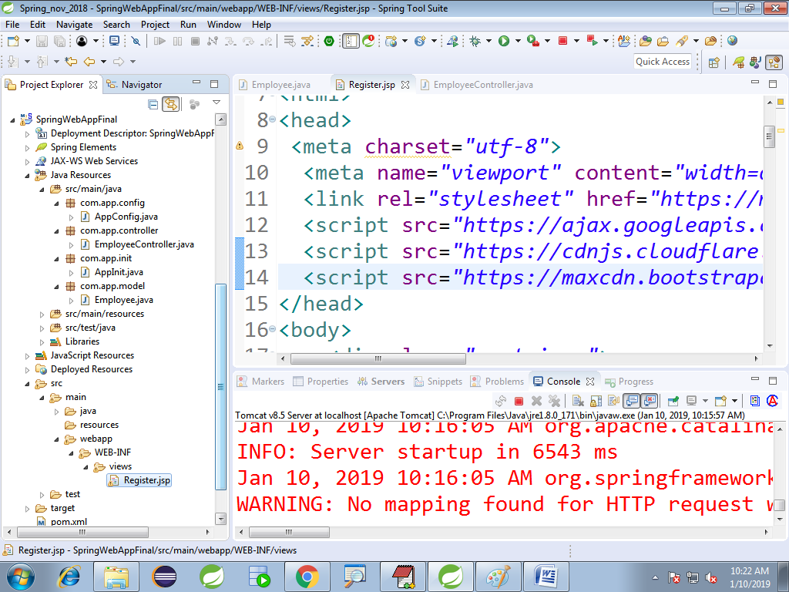

**pom.xml:-**

<dependencies>

<!-- Spring WEB -->

<dependency>

<groupId>org.springframework</groupId>

<artifactId>spring-webmvc</artifactId>

<version>5.0.6.RELEASE</version>

</dependency>

</dependencies>

<build>

<plugins>

<plugin>

<groupId>org.apache.maven.plugins</groupId>

<artifactId>maven-compiler-plugin</artifactId>

<version>3.7.0</version>

<configuration>

<source>1.8</source>

<target>1.8</target>

</configuration>

</plugin>

<plugin>

<artifactId>maven-war-plugin</artifactId>

<version>2.4</version>

<configuration>

<failOnMissingWebXml>false</failOnMissingWebXml>

</configuration>

</plugin>

</plugins>

</build>

**AppInit.java:-**

**package** com.app.init;

**import** org.springframework.web.servlet.support.AbstractAnnotationConfigDispatcherServletInitializer;

**import** com.app.config.AppConfig;

**public** **class** AppInit **extends** AbstractAnnotationConfigDispatcherServletInitializer{

@Override

**protected** Class<?>[] getRootConfigClasses() {

**return** **new** Class[] {AppConfig.**class**};

}

@Override

**protected** Class<?>[] getServletConfigClasses() {

**return** **null**;

}

@Override

**protected** String[] getServletMappings() {

**return** **new** String[] {"/"};

}

}

**AppConfig.java**

**package** com.app.config;

**import** org.springframework.context.annotation.Bean;

**import** org.springframework.context.annotation.ComponentScan;

**import** org.springframework.context.annotation.Configuration;

**import** org.springframework.web.servlet.config.annotation.EnableWebMvc;

**import** org.springframework.web.servlet.view.InternalResourceViewResolver;

@Configuration

@EnableWebMvc

@ComponentScan(basePackages="com.app")

**public** **class** AppConfig {

@Bean

**public** InternalResourceViewResolver ivr() {

InternalResourceViewResolver v=**new** InternalResourceViewResolver();

v.setPrefix("/WEB-INF/views/");

v.setSuffix(".jsp");

**return** v;

}

}

**Model class:-**

**package** com.app.model;

**import** java.util.List;

**public** **class** Employee {

**private** String empName;

**private** String empMail;

**private** String empPwd;

**private** String empGen;

**private** String empAddr;

**private** String empCntry;

**private** List<String> empLangs;

**public** Employee() {

**super**();

}

**public** String getEmpName() {

**return** empName;

}

**public** **void** setEmpName(String empName) {

**this**.empName = empName;

}

**public** String getEmpMail() {

**return** empMail;

}

**public** **void** setEmpMail(String empMail) {

**this**.empMail = empMail;

}

**public** String getEmpPwd() {

**return** empPwd;

}

**public** **void** setEmpPwd(String empPwd) {

**this**.empPwd = empPwd;

}

**public** String getEmpGen() {

**return** empGen;

}

**public** **void** setEmpGen(String empGen) {

**this**.empGen = empGen;

}

**public** String getEmpAddr() {

**return** empAddr;

}

**public** **void** setEmpAddr(String empAddr) {

**this**.empAddr = empAddr;

}

**public** String getEmpCntry() {

**return** empCntry;

}

**public** **void** setEmpCntry(String empCntry) {

**this**.empCntry = empCntry;

}

**public** List<String> getEmpLangs() {

**return** empLangs;

}

**public** **void** setEmpLangs(List<String> empLangs) {

**this**.empLangs = empLangs;

}

@Override

**public** String toString() {

**return** "Employee [empName=" + empName + ", empMail=" + empMail + ", empPwd=" + empPwd + ", empGen=" + empGen

+ ", empAddr=" + empAddr + ", empCntry=" + empCntry + ", empLangs=" + empLangs + "]";

}

}

**Controller class:-**

**package** com.app.controller;

**import** org.springframework.stereotype.Controller;

**import** org.springframework.ui.ModelMap;

**import** org.springframework.web.bind.annotation.ModelAttribute;

**import** org.springframework.web.bind.annotation.RequestMapping;

**import** org.springframework.web.bind.annotation.RequestMethod;

**import** com.app.model.Employee;

@Controller

**public** **class** EmployeeController {

//1. Show Form

@RequestMapping("/reg")

**public** String showReg(ModelMap map) {

//Fom Backing Object

Employee ee=**new** Employee();

//key name must be same as modelAttribute at <form>

map.addAttribute("employee",ee);

**return** "Register";

}

//2. on click submit show data

@RequestMapping(value="/save",method=RequestMethod.***POST***)

**public** String saveData(

//Reading Form Data

@ModelAttribute("employee")Employee emp,

//used to send data to UI

ModelMap map) {

//sending message to UI

map.addAttribute("message", emp);

//clear form - empty object

map.addAttribute("employee",**new** Employee());

**return** "Register";

}

}

**Register.jsp**

<%@ page language=*"java"* contentType=*"text/html; charset=ISO-8859-1"*

pageEncoding=*"ISO-8859-1"*%>

<%@taglib prefix=*"form"* uri=*"http://www.springframework.org/tags/form"*%>

<!DOCTYPE html PUBLIC "-//W3C//DTD HTML 4.01 Transitional//EN" "http://www.w3.org/TR/html4/loose.dtd">

<html>

<head>

<meta charset=*"utf-8"*>

<meta name=*"viewport"* content=*"width=device-width, initial-scale=1"*>

<link rel=*"stylesheet"* href=*"https://maxcdn.bootstrapcdn.com/bootstrap/4.1.3/css/bootstrap.min.css"*>

<script src=*"https://ajax.googleapis.com/ajax/libs/jquery/3.3.1/jquery.min.js"*></script>

<script src=*"https://cdnjs.cloudflare.com/ajax/libs/popper.js/1.14.3/umd/popper.min.js"*></script>

<script src=*"https://maxcdn.bootstrapcdn.com/bootstrap/4.1.3/js/bootstrap.min.js"*></script>

</head>

<body>

<div class=*"container"*>

<div class=*"card"*>

<div class=*"card-header bg-info text-white"*>

<h3>Welcome to Employee Register Page</h3>

</div>

<div class=*"card-body"*>

<form:form action=*"save"* method=*"POST"* modelAttribute=*"employee"*>

<div class=*"form-group"*>

<label for=*"empName"*>NAME</label>

<form:input path=*"empName"* />

</div>

<div class=*"form-group"*>

<label for=*"empMail"*>Email </label>

<form:input path=*"empMail"* />

</div>

<div class=*"form-group"*>

<label for=*"empPwd"*>PASSWORD</label>

<form:password path=*"empPwd"* />

</div>

<div class=*"form-group"*>

<label for=*"empGen"*>GENDER</label>

<form:radiobutton path=*"empGen"* value=*"Female"* />

Female

<form:radiobutton path=*"empGen"* value=*"Male"* /> Male

</div>

<div class=*"form-group"*>

<label for=*"empAddr"*>Address</label>

<form:textarea path=*"empAddr"* />

</div>

<div class=*"form-group"*>

<label for=*"empCntry"*>COUNTRY</label>

<form:select path=*"empCntry"*>

<form:option value=*""*>-SELECT-</form:option>

<form:option value=*"IN"*>INDIA</form:option>

<form:option value=*"AU"*>AUS</form:option>

<form:option value=*"EN"*>ENG</form:option>

</form:select>

</div>

<div class=*"form-group"*>

<label for=*"empLangs"*>LANGUAGES</label>

<form:checkbox path=*"empLangs"* value=*"ENG"* />

ENG

<form:checkbox path=*"empLangs"* value=*"HIN"* />

HIN

<form:checkbox path=*"empLangs"* value=*"TEL"* />

TEL

</div>

<div class=*"form-group"*>

<input type=*"submit"* value=*"Register"* class=*"btn btn-primary"* />

</div>

</form:form>

</div>

<div class=*"card-footer"*>${message}</div>

</div>

</div>

</body>

</html>

**output:**

